Sustainability Considerations for FY2022 Budget Planning

Sustainability can be framed as the collaborative, systems-based pursuit of long-term health, justice, and prosperity in our natural world, throughout our communities, and among ourselves.

To achieve sustainability, decision makers must reflect on how their actions will impact both people and the planet, consider multi-objective tradeoffs, and deliberately seek to minimize negative consequences. Generally, decisions that foster sustainability will seek to minimize energy use, resource consumption, and the production of waste (including pollution and carbon emissions); foster native ecosystems and biodiversity; enhance social equity and wellness; and mitigate, or increase resilience to, future risks. Decisions at all levels, from strategic planning to general purchasing to individual resource use, can contribute to institutional sustainability.

When planning for the FY2022 budget, we would like to support activities that will plan for, develop, and/or implement strategies and practices that will make Mason a more sustainable university. As you make your FY22 budget requests, please review sustainability practices 1-4 below. Mason will prioritize activities that incorporate these practices into planned strategies and activities. Please indicate which practices (1-4) your activities incorporate and/or address, if any, in the drop-down menu provided in the Budget Information Request System (BIRS) template. Select more than one practice, if applicable.

SUSTAINABILITY PRACTICES
Click on the tiles for more information!

- Reduce energy and resource use, and minimize waste
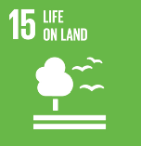
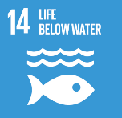
When seeking to reduce energy and resource use and minimize waste and pollution, decision-makers should first consider if the proposed action is necessary, or whether the objectives can be achieved in other ways. Reductions can also be achieved by:

- Reusing or repurposing materials
- Maintaining buildings, equipment, and consumer products to maximize lifespan and operational efficiency
- Prioritizing shared use of existing resources, including building spaces
- Prioritizing the use of products made from recycled materials
- Minimizing travel (including commuting)
- Maximizing energy efficiencies
- Utilizing renewable energy sources

Decision-makers should also consider offsetting unavoidable carbon emissions using certified carbon offsets.
- RESOURCES FOR
ENERGY AND WASTE MINIMIZATION

- Carbon Neutral certification guidelines (many product types)
- US EPA/US DOE Energy Star guidelines (office equipment, appliances, more)
- Epeat (electronics reuse and recycling)
- Forest Stewardship Council certification (paper, wood, and forest products)
- Green-e guidelines (energy, carbon offsets)
- Green Seal guidelines (Furniture, paper, cleaning products)
- ISO 1400x criteria (many product types)

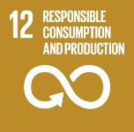
- Foster native ecosystems and biodiversity
Healthy native ecosystems provide a wealth of services that help ensure sustainability, and are compatible with much of the University’s built environment. Decisions that foster healthy ecosystems on, and beyond, the Mason campuses might include:

- Minimizing the use of non-native plants
- Eliminating invasive species
- Supporting native insect, bird, plant, and animal populations and habitats
- Reducing or eliminating the use of pesticides and herbicides
- Minimizing irrigation, especially spray irrigation
- Decreasing storm water runoff

2. RESOURCES FOR
NATIVE ECOSYSTEMS & BIODIVERSITY

- Fair Trade certification (textiles, food)
- Forest Stewardship Council criteria (paper, wood)
- USDA Organic guidelines (food, textiles)

Decision-makers should also consider selecting products that are certified sustainable, organic, or environmentally friendly.

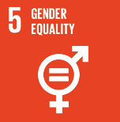
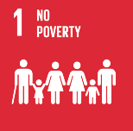
- Enhance social equity and wellness
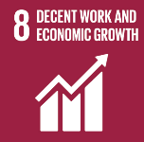
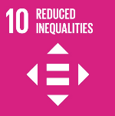
Healthy, sustainable communities are founded on equity and mutual respect for all persons. Actions that value diversity, reduce inequities, preserve dignity, and ensure equal access to opportunities and resources, both for Mason employees and members of the global community, help create and maintain sustainable communities. Actions that foster this goal might include:

- Choosing local suppliers, contractors, etc.
- Avoiding goods made with forced, child, or prisoner labor
- Choosing goods and services rendered with fair labor practices
- Valuing employees’ skills, personal needs, and working to build their capacities
- Nominating diverse team members for promotion, leadership positions, or supervisory roles
- Supporting leaders and supervisors of color with resources and effort
- Reducing waste and/or pollution where it impacts communities of color and/or low-to-moderate income communities
- Implementing and supporting healthy work-life balance policies and practice

- RESOURCES FOR
ENHANCING SOCIAL EQUITY AND WELLNESS

- Mason’s Anti-Racism and Inclusive Excellence Task Force
- Fair Trade principles (textiles, food)
- Certified B Corporation principles
- VA SWaM (Small, Woman- And Minority-Owned) certification

- Mitigate risk and increase resilience
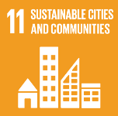
Planning for sustainability can yield better resilience to future shocks. Both natural and social science show that more diverse, more natural, and more equitable systems are better prepared to withstand, resist, or adapt to future changes. In many ways, sustainability is the pursuit of resilience. Actions that increase resilience might include:

- Accounting for a climate-changed meteorological future
- Planning for sea-level rise in coastal locations
- Recognizing additional stressors on human populations, including physiological, economic, and psychological stressors
- Protecting and restoring natural ecosystems
- Planning for increased human migration, domestically and globally
- Training, retraining, and educating the University community for resilience

- RESOURCES FOR
RESILIENCE PLANNING AND RISK MITIGATION
- Fairfax County Climate Adaptation and Resilience Plan
- Northern Virginia Regional Commission resilience principles
- Resilient Virginia principles
- United States Green Building Council principles

Barriers to Sustainability
As you consider incorporating sustainability into your budget planning, please take note of any barriers that you encounter, or anticipate, to implementing sustainability practices. We want to understand what obstacles will need to be removed to make Mason a sustainable university, and we will discuss these during future planning conversations.

Questions?
If you have questions about sustainability, or would like to discuss sustainability guidelines for budget planning, please contact the Office of Sustainability:

Greg Farley
Director of University Sustainability
703-993-5315
gfarley@gmu.edu
Website: green.gmu.edu

PREPARED AT THE DIRECTION OF
THE MASON SUSTAINABILITY COUNCIL
CAROL KISSAL, SENIOR VICE PRESIDENT
and
MARK GINSBERG, PROVOST AND EXECUTIVE VICE PRESIDENT
CO-CHAIRS

